Master I Shkencave T.I.K

Lenda:Analize Biznesi

Punoi:Oliger Shehi

Tema:BPMN e nje biznesi online.

-Chat AI me disa pyetje te thjeshta.

BPMN e Internet Provider

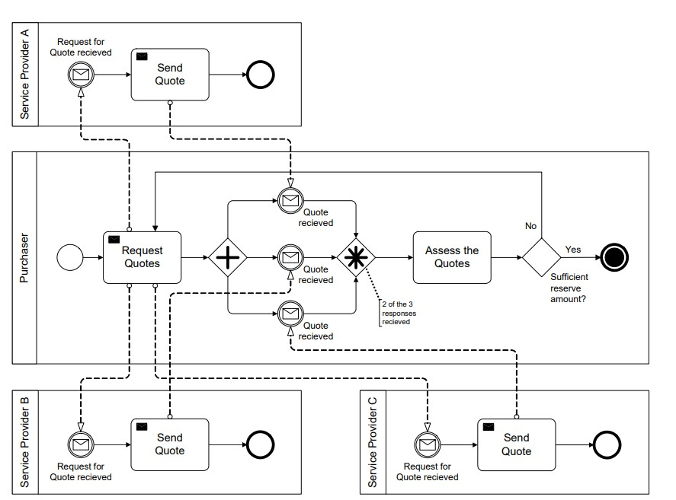

Aktoret ne kete BPMN jane:

1.Marresi i Sherbimit

2.Service provider 1

3.Service provider 2

4.Service provider 3

Klienti ne kete proces:

1:Marresi i sherbimit

Metrikat

1:Shpejtesia e dergimit

2:Koha

3:Error rate

Ingredientet

1Send quotes

2:Request quotes

3:Assess the quote

AI-Chat me disa fjale te thjeshta.

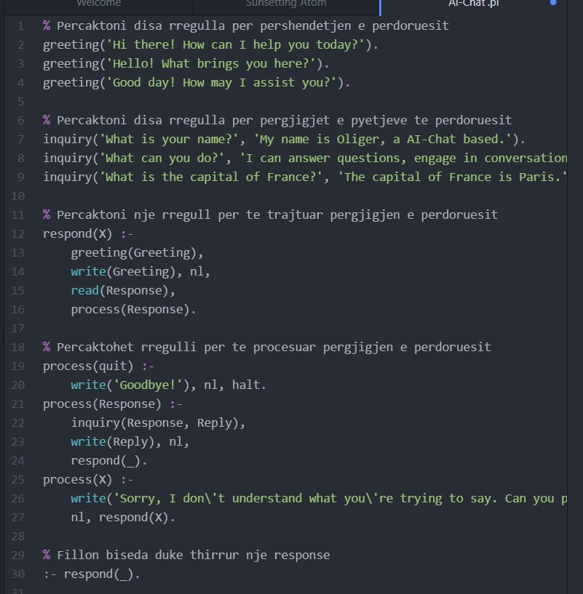

Nje shembull i implementimit te AI.

